Week: 6

Period: 2
PROGRESS REVIEW 3
I. AIMS:
- Language contents:
- VOCABULARY Units of measurement
- READING Meals for medals
- LANGUAGE FOCUS Making comparisons
- VOCABULARY AND LISTENING Jobs and skills
- Knowledge: By the end of the lesson, my students will be able to check their progress.
Main skills : reading, writing and listening skills.
Sub skills : speaking skills.
3. Attitude: be confident to do the exercises and then complete their own evaluation.
4.Competences:
- make guesses and indicate when they’re not sure.
- guess words in a text they don’t know by looking at the context
- make comparisons.
- understand people talking about skills.
II. TEACHER’S AND STUDENTS’ PREPARATIONS:
- Teacher: textbooks, powerpoint slides, ….
- Students: textbook, notebook.
III. TECHNIQUES: Qs& As, games, visualize….
IV. PROCEDURES:
Content | Answer key
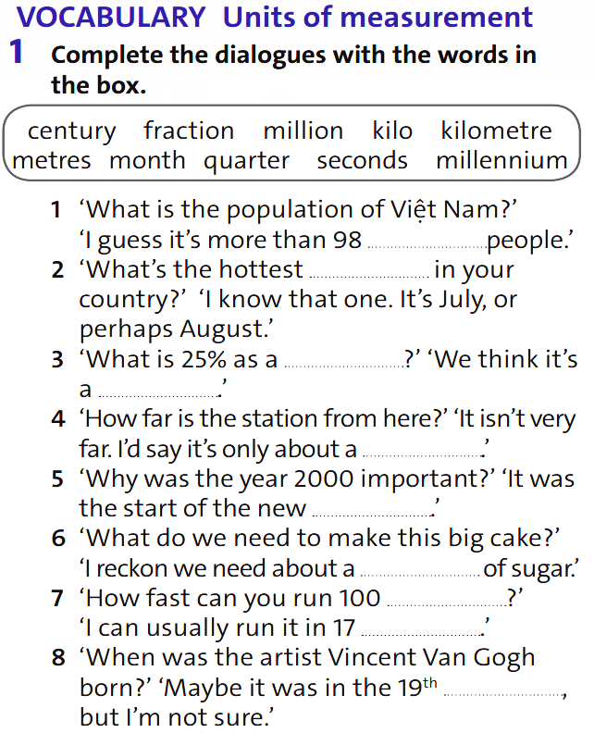  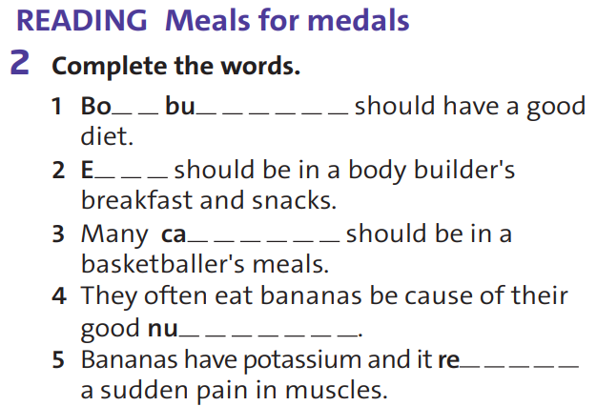  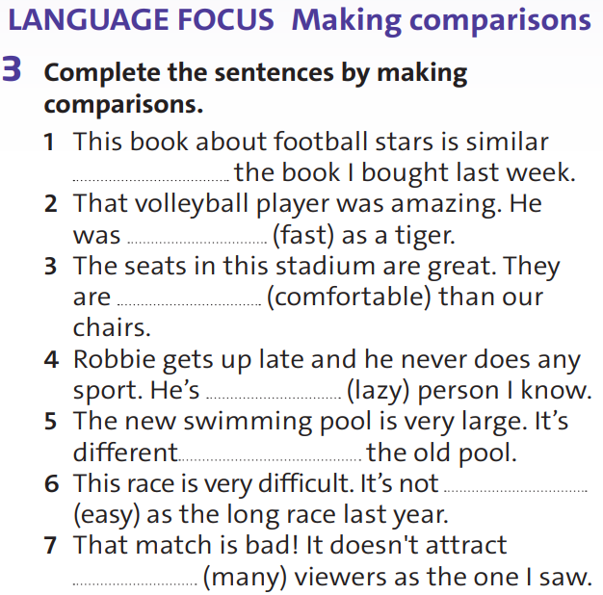  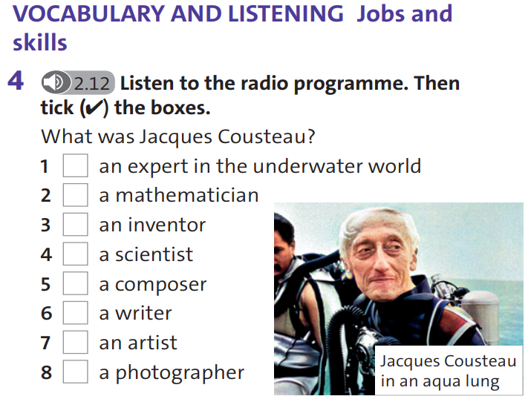 | 1)  1 million  2 month  3 fraction, quarter  4 kilometre  5 millennium  6 kilo  7 metres, seconds  8 century  2)  1 bodybuilder  2 eggs  3 calories  4 nutrients  5 reduces  3)  1 to  2 as fast  3 more comfortable  4 the laziest  5 from  6 as easy  7 as many  4)  1, 3, 4, 6, 8
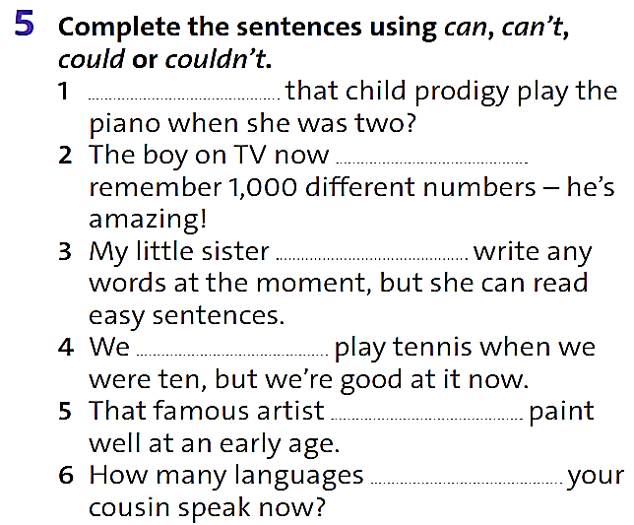  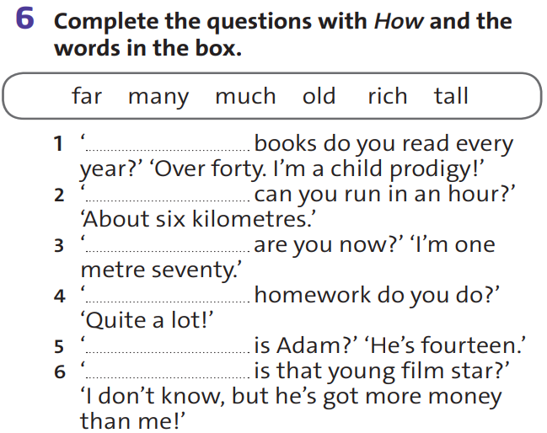  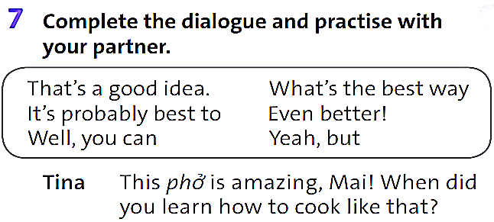  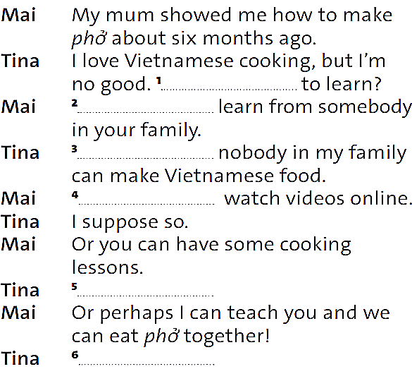  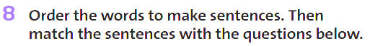  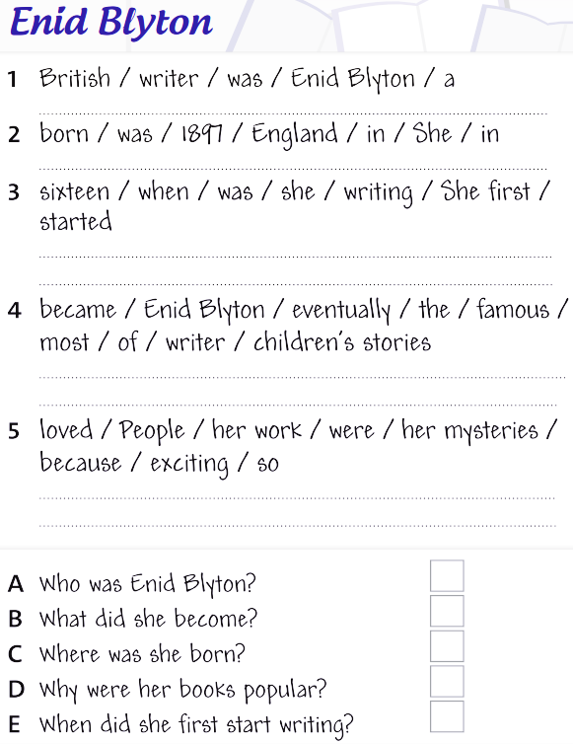 | 5)  1 Could  2 can  3 can’t  4 couldn’t  5 could  6 can  6)  1 How many  2 How far  3 How tall  4 How much  5 How old  6 How rich  7)  1 What’s the best way  2 It’s probably best to  3 Yeah, but  4 Well, you can  5 That’s a good idea.  6 Even better!  8)  1 Enid Blyton was a British writer.  2 She was born in England in 1897.  3 She first started writing when she was 16.  4 Enid Blyton eventually became the most famous writer of children’s stories.  5 People loved her work because her mysteries were so exciting.  A 1  B 4  C 2  D 5  E 3
V. Homework. | - Prepare Progress Review Ex 9, 10, 11, 12

Week: 6

Period: 3
PROGRESS REVIEW 3 (cont)
I. AIMS:
1. Language contents:
- VOCABULARY Survival verbs
- READING Jungle challenge
- LANGUAGE FOCUS will and won’t in the first conditional
- VOCABULARY AND LISTENING Survival equipment
2.Knowledge: By the end of the lesson, my students will be able to check their progress.
Main skills : reading, writing and listening skills.
Sub skills : speaking skills.
3. Attitude: be confident to do the exercises and then complete their own evaluation.
4.Competences:
- talk about what to do in a challenging situation.
- identify text types and predict the content.
- talk about actions and their results.
- predict some of the things from the recording.
II. TEACHER’S AND STUDENTS’ PREPARATIONS:
1.Teacher: textbooks, powerpoint slides, ….
2.Students: textbook, notebook.
III. TECHNIQUES: Qs& As, games, visualize….
IV. PROCEDURES:
Content | Answer key
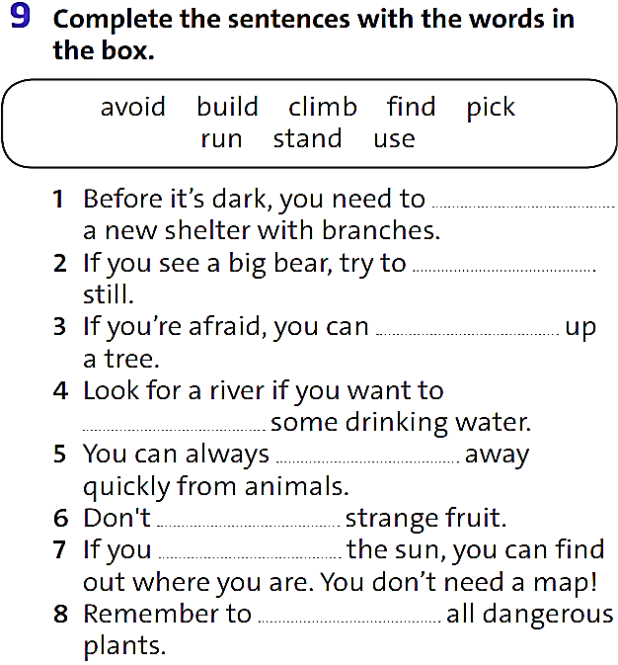  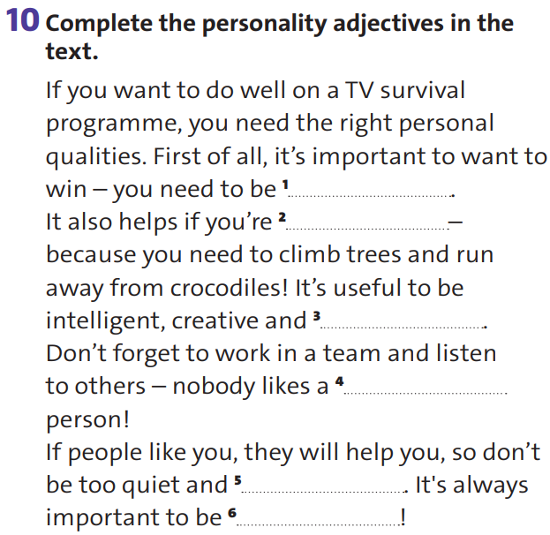  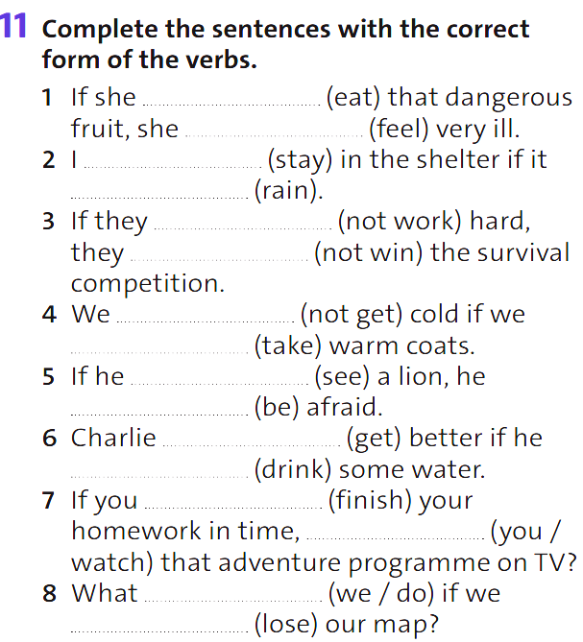  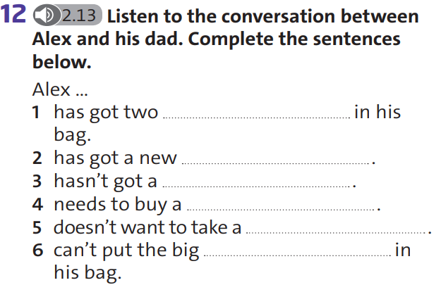 | 9)  1 build  2 stand  3 climb  4 find  5 run  6 pick  7 use  8 avoid  10)  1 competitive  2 fit  3 clever  4 bossy  5 reserved  6 friendly  11)  1 eats, ’ll feel  2 ’ll stay, rains  3 don’t work, won’t win  4 won’t get, take  5 sees, ’ll be  6 will get, drinks  7 finish, will you watch  8 will we do, lose  12)  1 water bottles  2 sleeping bag  3 knife  4 compass  5 first-aid kit  6 torch
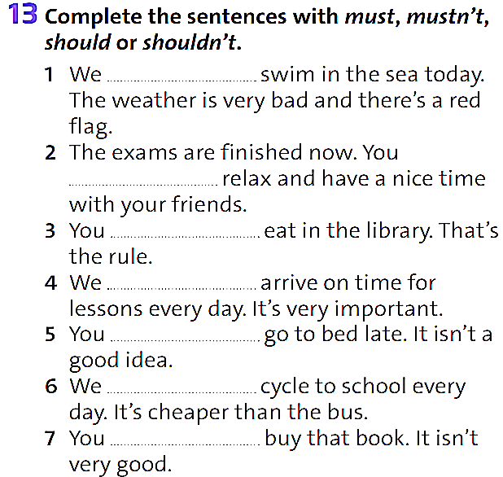  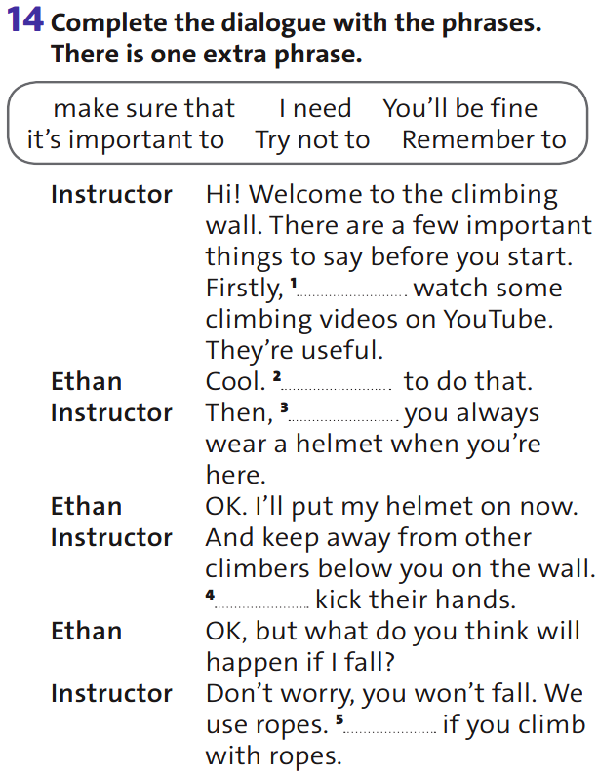  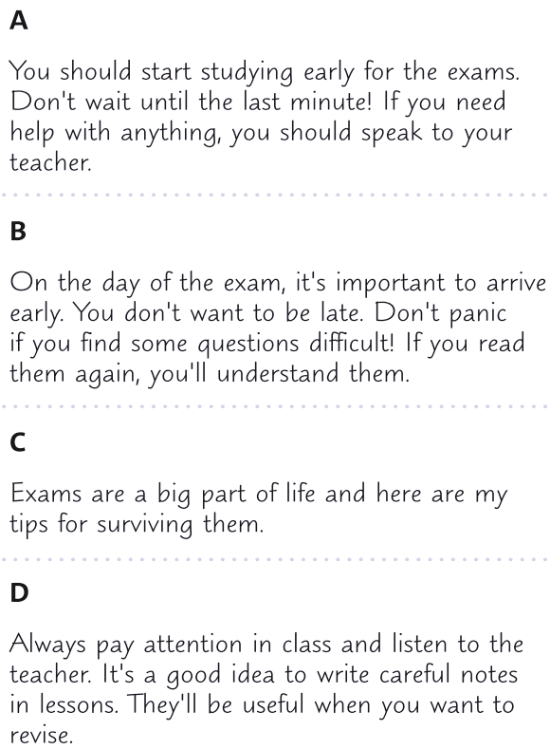 | 13)  1 mustn’t  2 should  3 mustn’t  4 must  5 shouldn’t  6 should  7 shouldn’t  14)  1 it’s important to  2 I need  3 make sure that  4 Try not to  5 You’ll be fine  15) C D A B
V. Homework. | - Revise Unit for Mid-term test II

